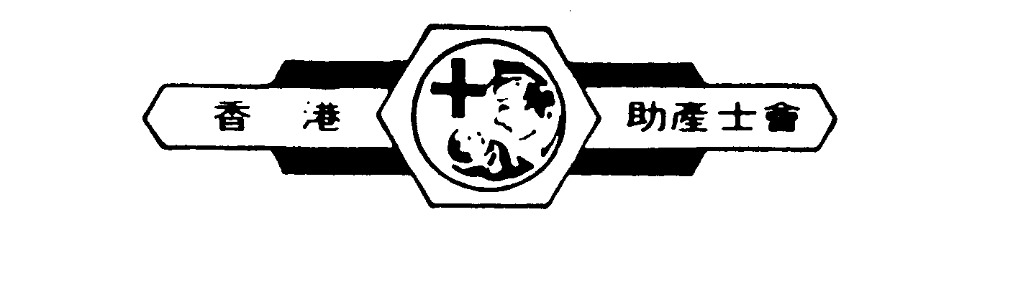  香港灣仔告士打道  223號  海聯大廈13樓D1 | 香港助產士會  Hong Kong Midwives Association | D1, 13/F, Hyde Centre,  223 Gloucester Road,  Wanchai, Hong Kong  Tel : 28938800 Fax: 25725329  Email: midwives@netvigator.com
入會申請/更新資料表格

MEMBERSHIP APPLICATION/RENEWAL FORM

英文姓名 (請以正楷填寫) Name in English (In block letters) |  | 中文姓名 Name in Chinese
Year of Birth 出生年份 |  | HKID NO. the letters and the first 3 digits  身份証號碼 (只須填寫英文字母及頭3位數字)
地址 Address

聯絡電話號碼 Contact tel. no.
住宅 Home : 工作 Work : 手提 Mobile :.
電郵 E-mail | 傳真 Fax no.
工作機構 Employing organization | 職位/部門 Present post/Department
香港護士局註冊編號及註冊日期 Hong Kong Nursing Council Registration no. and date of registration

香港助產士局註冊編號及註冊日期 Hong Kong Midwives Council Registration no. and date of registration

會員類別 Membership Type
永久Life 普通Full 附屬 Associate

只供本會填寫 For official use only

Date of application | Membership no.
Fee | Cheque no. (Bank)
Approved by

Name in block : Signature : Date :
Remarks

備注 Remarks :

- 填妥表格後，請連同入會費 (劃線支票註明收款人為「香港助產士會」) 並在支票背面註明姓名及聯絡電話寄回本會。

Please send the completed application form together with registration fee. Kindly state your name and contact telephone number at the back of the cheque (crossed cheque payable to "Hong Kong Midwives Association")

